Join the Nature Center in Guovdageaidnu!
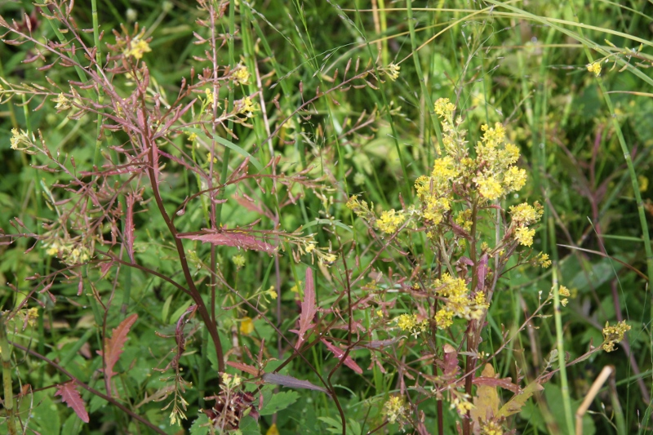
If you take part in building Guovdageaidnu nature center you will contribute to:
– making a meetingplace for everybody who bother about nature.
– strengthen our knowledge about nature.
– getting more attractions, jobs and tourists to Guovdageaidnu.
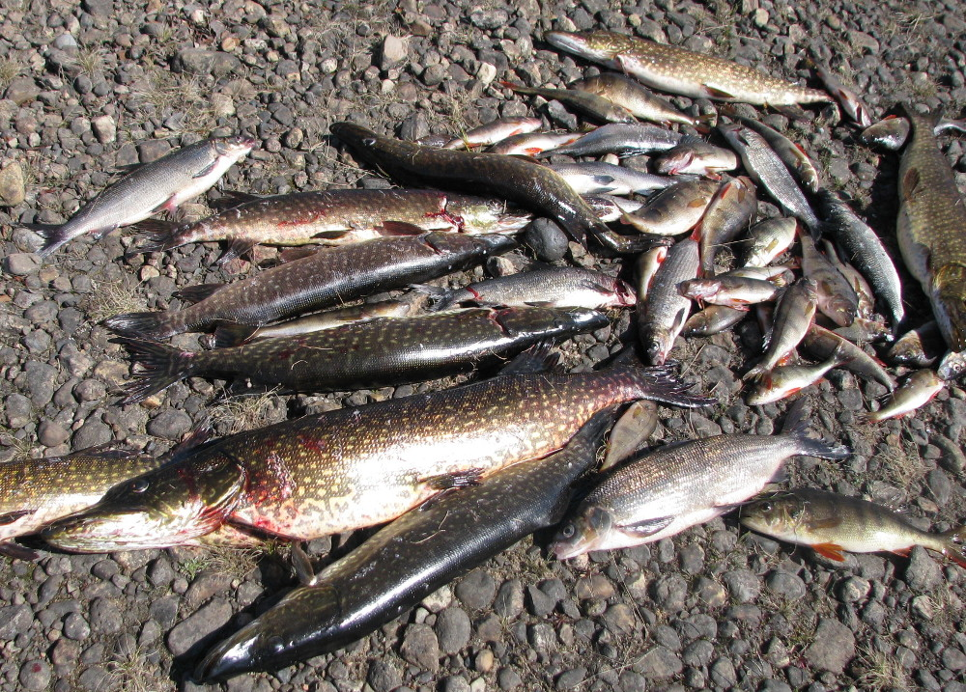 | How you can contribute:  – Become a member of the Center. Membership is 100kr a year /1000kr for a lifetime. For companies/organizations 1000kr /10000kr.  – Give general monetary support or for projects.  – Give/lend pictures, equipment, goods for cafeteria and other useful things.  You may pay to our account 1254.62.91144 or Vipps 545709
What we have done:  - Arranged courses about use of nature's goods.  - Built up website http://meahcci.info about nature, nature conservation and intervention.  - Created exhibition about birds, fish, plants, reindeer husbandry, mines and power development.  - Arranged an Easter arrangement in 2018 with exhibition, courses, lectures and café.  - Collected 400 books and 200 stones  - Systematized Sami plant and animal names for the Species Database (www.artsdatabanken.no) | 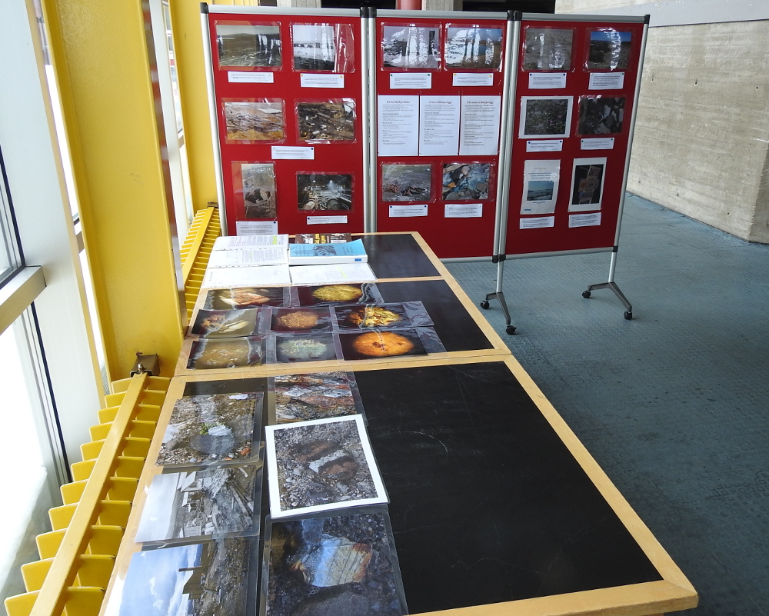
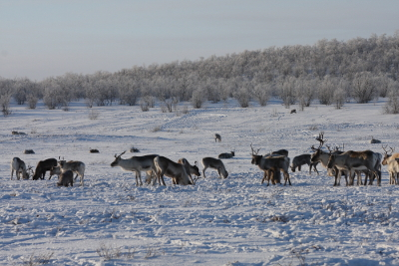 | Plans and ideas for the future:  - Exhibitions about our national parks, bonfires, mushrooms etc.  - Develop website as a knowledge base about nature in Finnmark  - Geological exhibition and Geology Day  - Nature and cultural path in the village with bird tower, bonfires and use of empty premises.  - Develop and sell local natural products.  - More courses and offers for schools, children, youth and immigrants.  - Continue and improve the Easter arrangement  - Become the center for scientific nature surveys  - Seminars about nature management
Guovdageainnu meahcceguovddáš (Nature Center)
http://meahcci.info, meahcci@meahcci.info, Office: Culture House, org.nr. 921362595
Tel. 46189976 / 9072769

